Sue

Quote as follows for 20 Mothers and Widows badge inc small gold plaque, storage box $44.00 each + postage $910.00

Could you please confirm plaque – size will sit nicely inside lid on on outside whichever you prefer (in gold)

4.5cm wide x 3cm deep

HMAS PATRICIA CAM
75th Anniversary
Yirrkala
24 April 2017

Medals of Service
PO Box 5922 South Windsor NSW 2756
Phone: 0245775083
www.medalsofservice.com.au
sales@medalsofservice.com.au
** please note Medals of Service no longer has a shop front - all orders will be posted
Direct Credit Details
ANZ Bank
Medals of Service
BSB 012321
Account Number 108743893
**please use surname or phone number as reference**

Swift Code ANZBAU3M (for Overseas banking)
** please note we will not accept Cheques or Money Transfers in any currency other than Australian Dollars

Mothers' and Widows' Badge
First World War Mothers and Widows badge AWM REL/05876
The First World War Mothers' and Widows' Badge was issued to the mother and/or widow of all members of the Australian Imperial Force (AIF) or the Australian Naval and Military Expeditionary Force who had been killed in action, died of wounds or other causes while on active service, or who, after discharge, had died of wounds or sickness directly attributable to that service.
The black ribbon was machine-embroidered in gold with wattle sprigs, a Rising Sun badge and the words "For Australia". The badges were suspended from a white metal bar which bore laurel leaves. Stars were added to the bottom bar, each indicating the death of one man. The badge was promulgated under Military Order 64 of 1919.
The Mothers' and Widows' Badge of the Second World War was to be issued to the mother and/or widow of a member of the Royal Australian Navy (RAN), AIF (including the Australian Army Nursing Service), Citizens Military Forces, or Royal Australian Air Force killed in action, or died of wounds or from other causes whilst on service or as a result of such service.
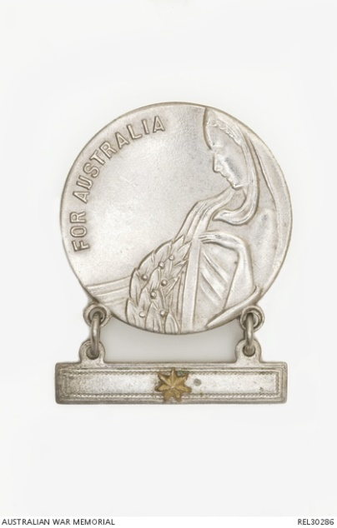
The Second World War badge was round and silver-coloured. The obverse shows a raised image of a woman and part of a laurel wreath with the words "For Australia" in raised letters. The reverse has a hinged securing pin and raised lettering which reads "Issued by the C'wlth Govt" and the manufacturer's details. Suspended by two securing rings from the bottom of the badge is a flat rectangular bar were stars were added, as with the First World War. Authority for the issue of the badge in the Second World War was issued under AIF Order 200 dated 14 February 1941.
Second World War Mothers and Widows badge REL30286
Mothers and widows eligible to receive the badge had to apply for it through a Post Office, using the correct form, which was then witnessed by a postal employee. The forms were then sent to the relevant service in which the woman's child/spouse had enlisted, for verification that the relative they had nominated was indeed in that service, before the badge could be issued. As mothers were often omitted as the listed next of kin they had to apply through this process and the difficulties that the application process sometimes caused may explain why not all women received a badge, or why some never bothered to apply.

