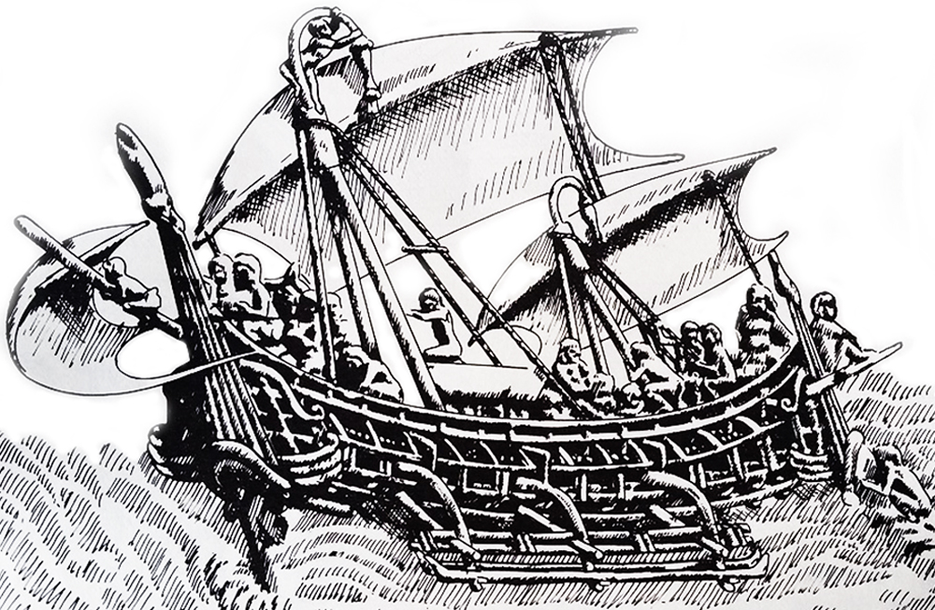
Medieval Javanese ship with tripod masts, canted rectangular sails, quarter-hung rudders, depicted in 8th-century temple frieze at Candi Borobudur, Central Java. Drawing by Chris Snoek, from The Prahu by Adrian Horridge, OUP, 1981
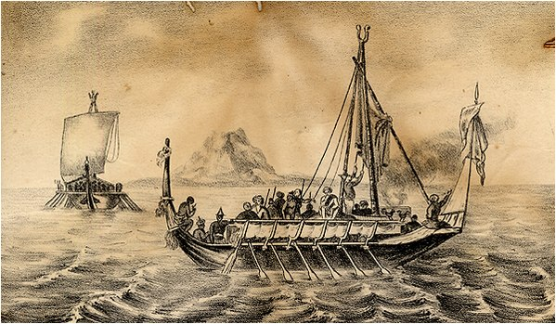
Banguingui, also known as Sama Banguingui or Samal Banguingui is a distinct ethno-linguistic group dispersed throughout the Greater Sulu Archipelago and southern and western coastal regions of the Zamboanga Peninsula in Mindanao, Philippines. They are one of the ethnic groups usually collectively known as the Sama-Bajau peoples. – Image: Garay warships of pirates in the Sulu Sea

The Balangingi Samal: The Global Economy, Maritime Raiding and Diasporic Identities in the Nineteenth-Century Philippines
James Francis Warren of Murdoch University
Pages 7-29 | Published online: 27 May 2010

Abstract
In the early nineteenth century, an entire ethnic group, the Samal Balangingi of the Sulu-Mindanao region, specialised in state-sanctioned maritime raiding, attacking Southeast Asian coastal settlements and trading vessels. This paper traces the process of the formation of the Samal Balangingi as an ethnic group comprised of 'pirates' and their captives, and their continued sense of belonging to the island stronghold of Balangingi, even after its inhabitants were forcefully resettled between 1848 and 1858. The paper also stresses just how critical the Spanish resettlement policy directed against the deported Samal Balangingi was for their future cultural and social life. It highlights the inextricable relationship between maritime raiding, slavery, forced migration, 'homeland' and cultural identity as being critical factors that led to the emergence of new ethnicities and diasporas. By highlighting the problems of self-definition and the reconstruction of identities and the meaning of homeland and lost places, as a revealing social and psychological process in its own right, the case of the Samal Balangingi challenges lineal notions of history and bounded static conceptions of 'culture' and ethnic groups that were imposed, imagined and maintained by Europeans both prior to and after colonisation.

Saltwater Slavers and Captives in the Sulu Zone, 1768–1878
James Francis Warren of Murdoch University
Pages 429-449 | Published online: 08 Sep 2010

Abstract
In the early nineteenth century several Malayo-Muslim ethnic groups, the Iranun and Samal-Balangingi, specialized in state-sanctioned maritime raiding, attacking Southeast Asian coastal settlements and shipping. This paper traces the slaving and raiding operations of these sea raiders and how the economy of their sponsor, the Sulu Sultanate, was integrated into the world-capitalist system. The paper stresses the motives behind their slave raids, the hazardous nature of their long distance expeditions, and the experience of their captives in the middle passage. It also highlights the background and origins of the Iranun and Balangingi, their raiding vessels and crews, their social organization, and daily life at sea.

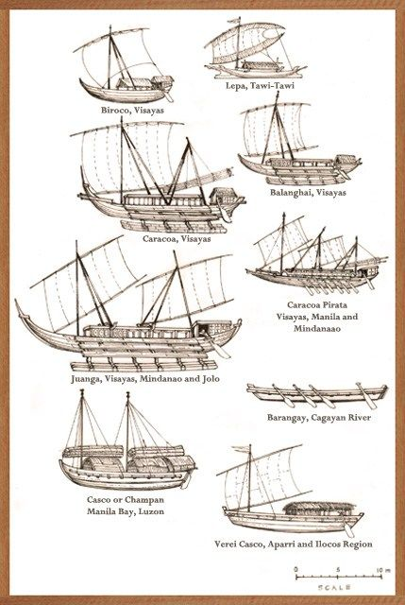
Filipino boats

