Garden Island
Chapel of Remembrance
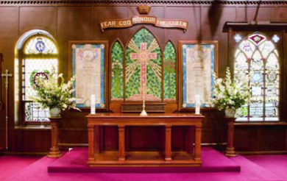
The Naval Chapel at Garden Island is the oldest chapel of the Royal Australian Navy. It was established in 1902 in a converted sail loft, and has stained glass windows and plaques from that era to the present.
The main chapel is on the upper level of the building, accessed by a winding staircase from the main entrance. The Chapel of Remembrance was incorporated into the space in 1996 during a modernisation of the building.
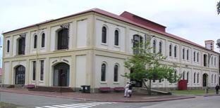
The Chapel of Remembrance was established to meet an ongoing need within some families of past serving members to enable them to create a lasting memorial to a member’s service as an expression of affection and grief.

The Chapel of Remembrance occupies an area under the main chapel. It was officially opened on 25 August 1996 by Rear Admiral David Campbell, AM RAN, Flag Officer Naval Support Command, and dedicated by Principal Chaplains Michael Holtz AM RANR, Gareth Clayton RAN and Chaplain J.F.B. Connelly RAN.
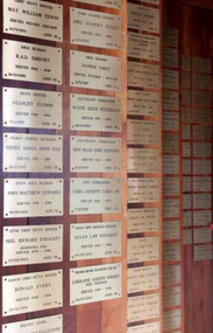
There is an earthy atmosphere with a sandstone plinth forming the basis of the altar and rough-hewn wooden columns giving a natural feeling to the space. The front wall is faceted to allow memorial plaques to be placed on the wooden screens.
Any former serving member of the Royal Australian Navy or Women’s Royal Australian Naval Service, regardless of rank, rate or time served may have a plaque dedicated to them.
The concept embodied in the memorial is that members are united through their common purpose of serving Australia. Every sailor and officer contributes to the efficient performance of the Navy’s duty in peace and war and has been an essential to the operation of Her Majesty’s Australian Ships.

Plaque Order Instruction

Thank you for your inquiry regarding the placing of a memorial plaque in the Chapel of Remembrance.

The policy followed by the administrators is to place 160mm by 100mm brass plaques inscribed with the following details: Service Number and Rank, Full name, Serving time e.g. 19**- 19**, Date of Death and Age at Death.

The formatting of the plaque is shown on the enclosed order form. This office will arrange supply on your behalf at the current cost of $40.00 this price covers the engraving of up to eighty characters. Please transfer the funds to the following account:

Branch: Australian Defence Credit Union
HMAS Kuttabul SCAF
BSB NO: 642 170
ACC NO: 100 252 660
REFERENCE: Memorial Plaque and your name

Please send a copy of the deposit slip and the completed enclosed plaque order form. Please print clearly on the form.
If necessary, you may verify Service details at the office of Navy records:

Department of Defence
Navy Records
Queanbeyan Annex
CANBERRA ACT 2600
Ph: (02) 6266 5967 - Fax: (02) 6266 5851

You will be advised when the plaque has been engraved and is to be placed in the Chapel.
All correspondence may be sent via email navychaplainenquiries@defence.gov.au or mail at:
Command Chaplaincy Centre
HMAS Kuttabul Building
67, 14-16 Wylde Street
Potts Point NSW 2011
Phone (02) 9359 3760 - Fax (02) 9359 2782

Our office opening hours are Monday – Thursday: 0730 – 1600,
Friday: 0730 – 1330. The office is closed on Saturday and Sunday.
RETURN TO:
Command Chaplaincy Centre
HMAS Kuttabul
Building 67, 14-16 Wylde Street
Potts Point NSW 2011
Phone (02) 9359 3760 - Fax (02) 9359 2782
navychaplain.enquiries@defence.gov.au

ORDER FORM
CHAPEL OF REMEMBRANCE

Name | ___________________________________________________________________________________
Address | ___________________________________________________________________________________ Suburb _____________________________________________________________________________ State__________________________________________________Postcode______________________
Contact | Telephone______________________________ Mobile ____________________________________  Email ______________________________________________________________________________
Relation of donor to Service member _______________________________________________________________
DETAILS OF DONOR
Rank | ____________________________________________________________________________
Name | ____________________________________________________________________________
Years of Service | From ________________________________ To ___________________________________
Date of Death | ________________________________Age at death_______________________________
Service number of member | ________________________________________________________  (Note: In the early years of the RAN, Officers were not given Service Numbers)
DETAILS TO BE INCLUDED ON THE MEMORIAL PLAQUE:



