Name: | William Robson Moffitt
Birth Date: | 23 Aug 1918
Birth Place: | Lockhart New South Wales
Year Range: | 1939 - 1948
Enlistment Place: | Melbourne
Service number: | 24501
Next of Kin: | Ethel Moffitt
Series Description: | A6770: RAN, Petty Officers and Men
Fitter & Turner
Brother in HMS Auberon? To be informed that rating is missing as a result of enemy action
AWM
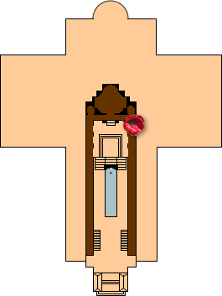
Service Number: 24501
Rank: Engine Room Artificer 4th Class
Unit: HMAS Patricia Cam
Service: Royal Australian Navy
Conflict / Operation: Second World War, 1939-1945
Conflict eligibility date: Second World War, 1939-1947
The official commencement and cut-off dates for inclusion in the Roll of Honour and the Commemorative Roll.
Date of death: 22 January 1943
Cemetery or memorial details: Plymouth Naval Memorial, Plymouth, Devon, England, United Kingdom
Source: AWM146 Roll of Honour cards, 1939-1945 War, Royal Australian Navy

William Robson Moffitt's name is located at 5 in the Commemorative Area at the Australian War Memorial (as indicated by the poppy on the plan).

Plymouth
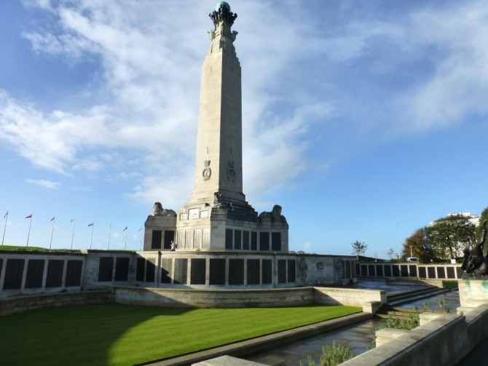
Rank:
Engine Room Artificer 4th Class
Service No:
24501
Date of Death:
22/01/1943
Age: 24
Regiment/Service:
Royal Australian Navy
H.M.A.S. Patricia Cam
Panel Reference:
Panel 83, Column 2.

Memorial:
PLYMOUTH NAVAL MEMORIAL
Additional Information:
Son of Joseph Henry and Ethel Lucy Ray Moffitt, of Corowa, New South Wales, Australia.

